**15CSE337 Cloud Computing and Services**

**Lab Practice Exercise 1**

Design the following registration form with necessary validations using HTML/CSS/JavaScript. When clicked on “Submit” button, you should show a second page with confirmation message. 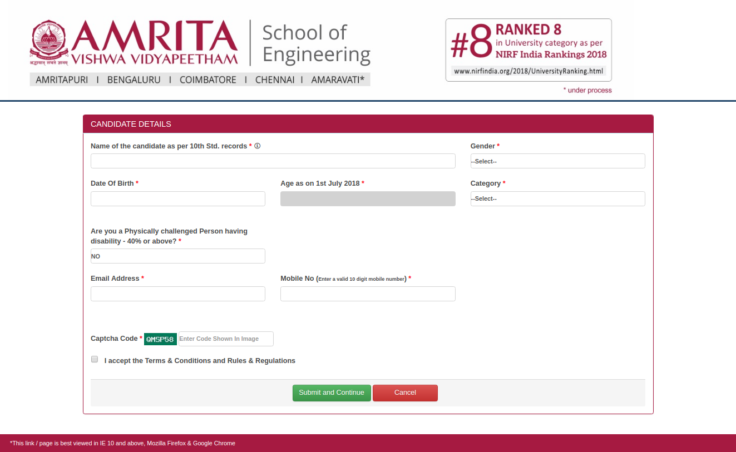

**Submit**

**Design considerations**

* You must use atleast one dropdown field and one radio button field.
* Age must be calculated based on date of birth automatically and hence age is a read only field
* Captcha code must be random each time we load the page
* Values for Gender are male, female, transgender
* Values for category as GEN, SC, ST, OBC
* Second page should have same header and footer elements as the registration page

**Validations**

* Date of Birth cannot be a future date
* Age has to be minimum of 15 years
* Email address must be valid
* Mobile number must be 10 digits
* Name must have minimum of two strings (illustrating first name and last name)



Footer

Header

**Submit**